

**Experimental Lab Student Report**

Week 4 Lab

Lab Title: File Systems

Student Name: Anthony Meunier

Date: 1/29/2014

After completing the activities, take a screenshot of the following and copy onto this report:

1. Activity 5-1, after #8 (16 points)

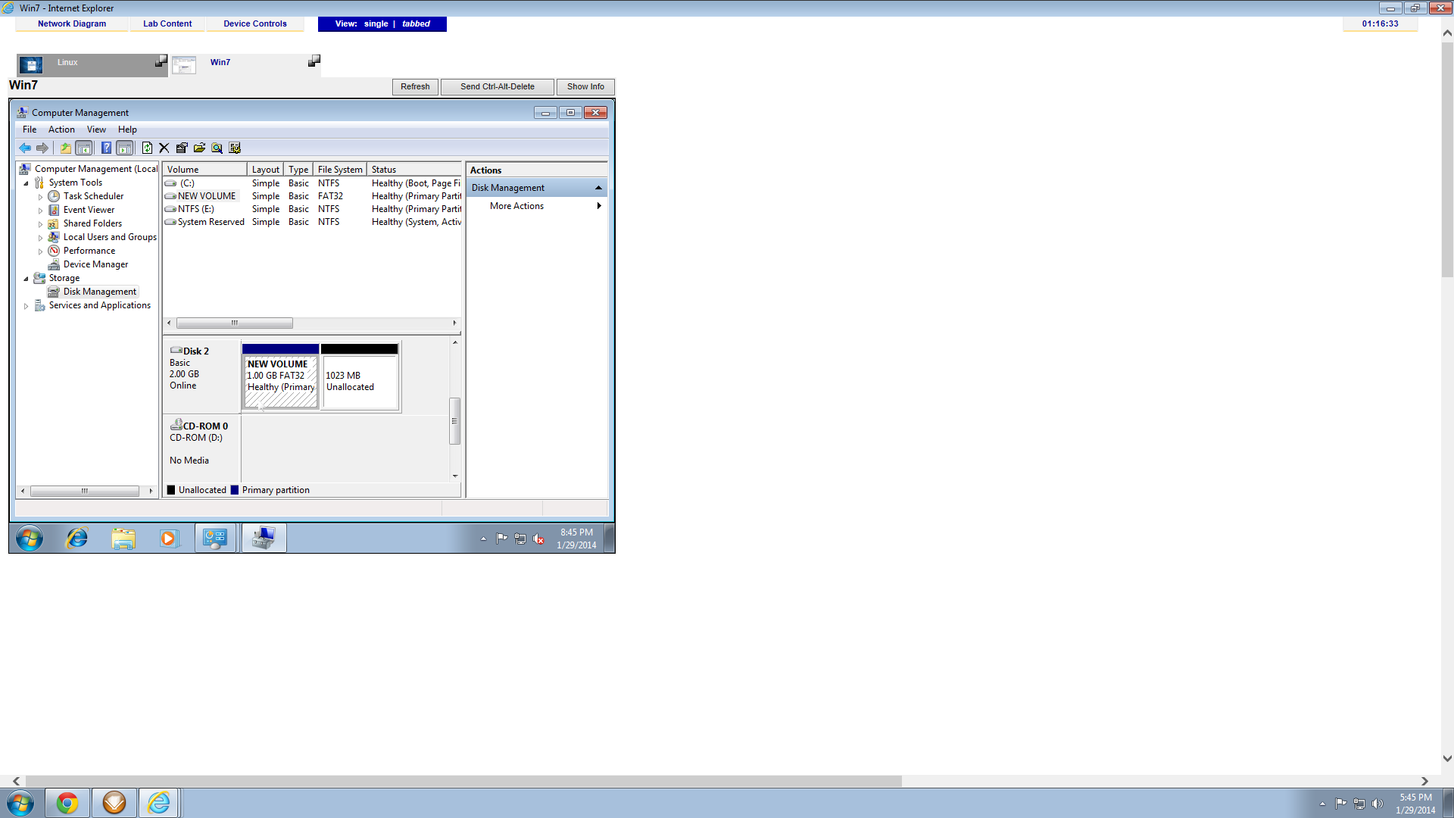

1. Activity 5-2 after #5 (17 points)

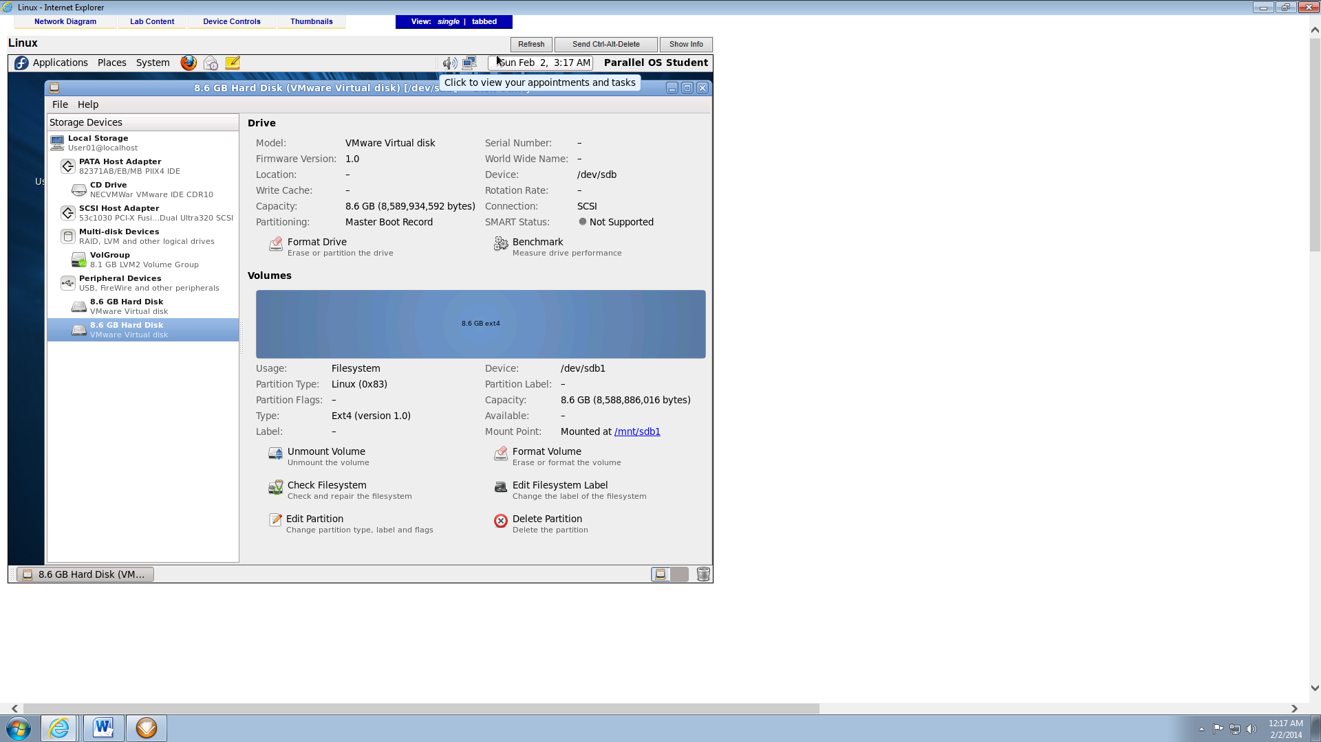

1. Activity 5-6, after #10. Remember to right-click on C: so you can see the mounted drive in the right panel. (17 points)

